ASSIGNMENT - 2

Data Visualization and Pre - processing

Assignment Date | 27 September 2022
Student Name | S.VIJAYALAKSHMI
Student Roll Number | 420619104039
Maximum marks | 2 Mark

1.Download the dataset : Dataset

https://drive.google.com/file/d/160K6XcuYDyRBPGj-JsqThkyFoJhCvOWy/view?usp=sharing

2.Load the dataset.

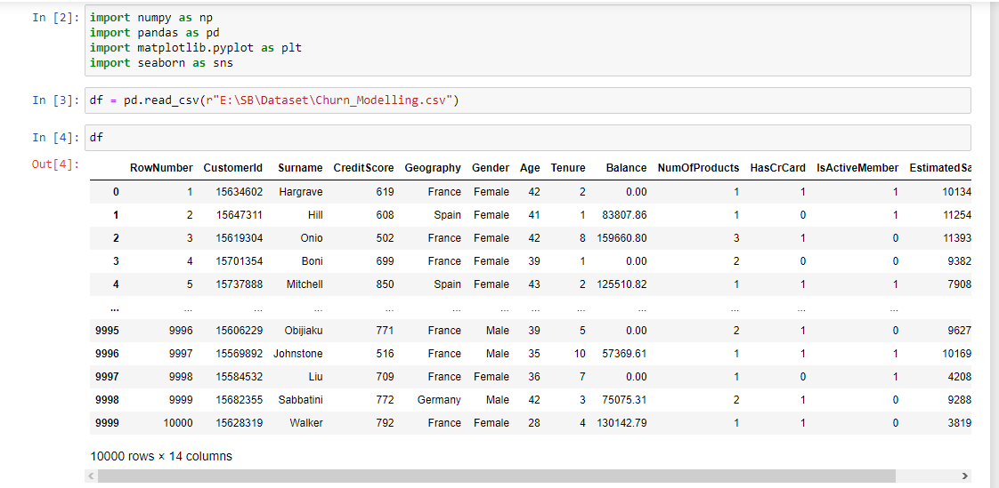

- Perform Below Visualizations:

* Univariate Analysis

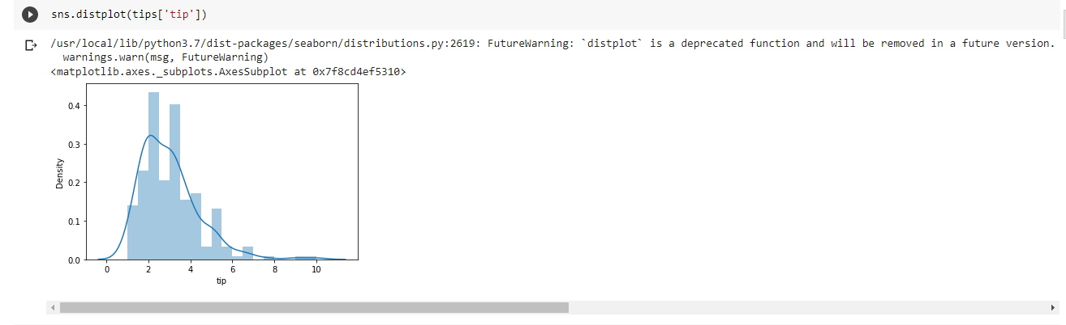

* Bi - Variate Analysis
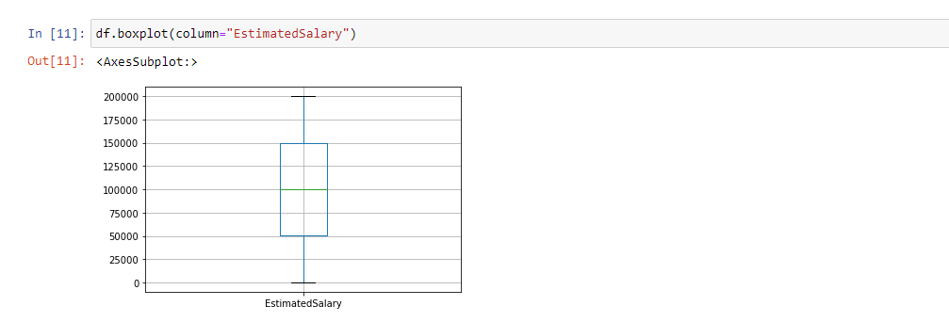

* Multi - Variate Analysis

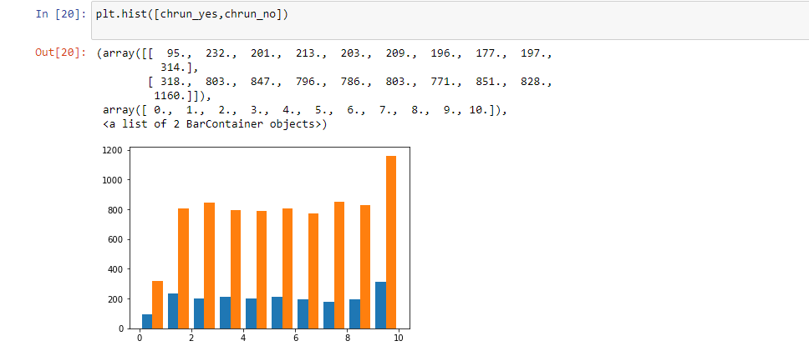

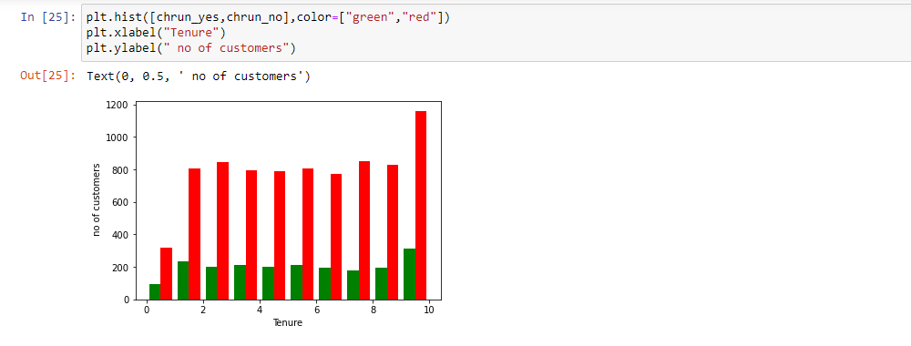

- Perform descriptive statistics on the dataset
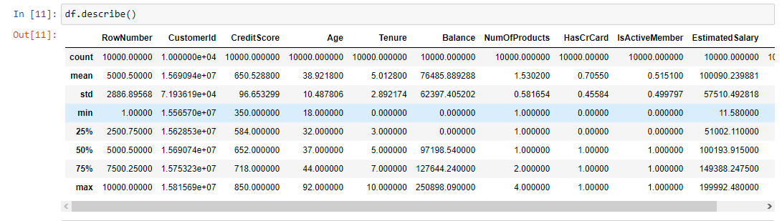

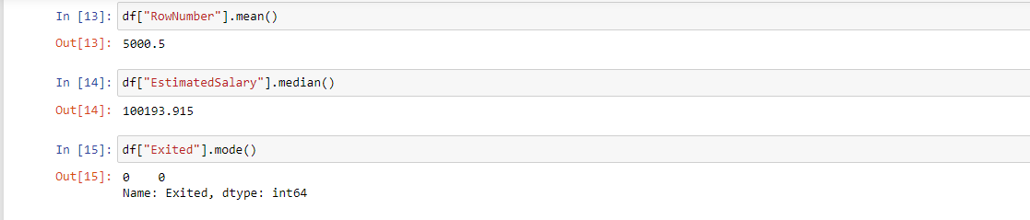

- Handle the Missing values.

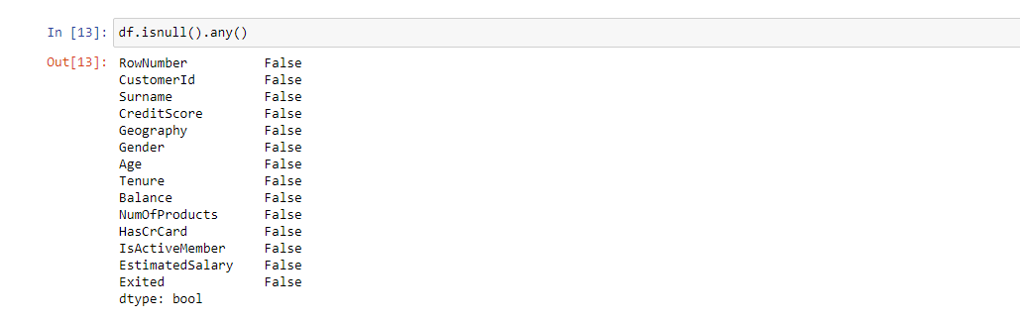

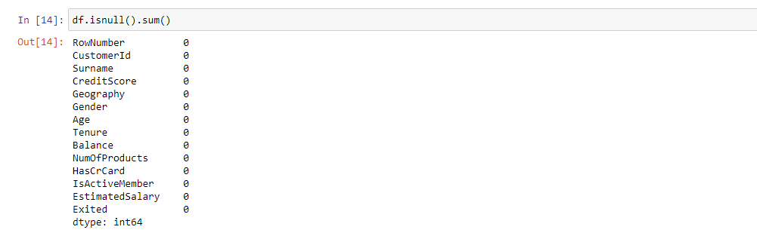

- Find the outliers and replace the outliers

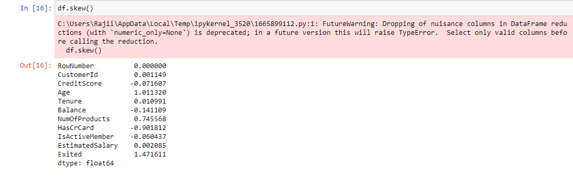

- Check for Categorical columns and perform encoding.

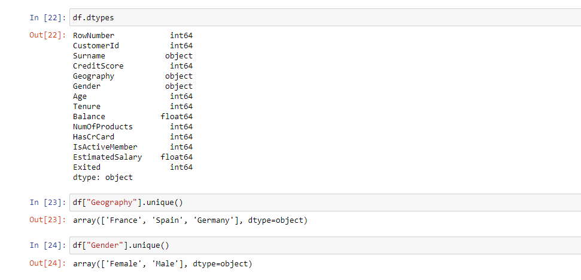

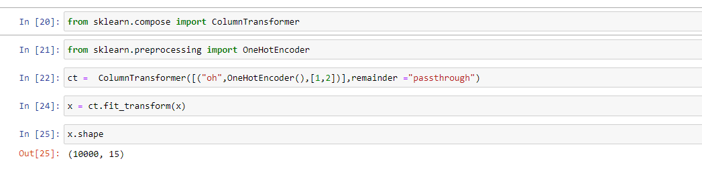

- Split the data into dependent and independent variables

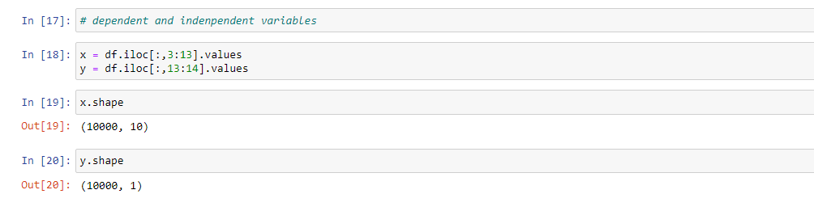

- Scale the independent variables

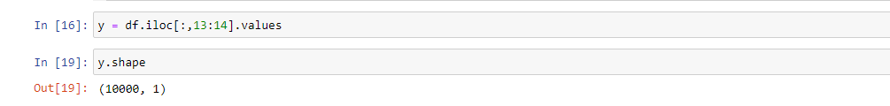

- Split the data into training and testing

